Emergency Service System

- Background description:
In recent decades, emergency services such as fire departments, ambulances, and law enforcement have become indispensable to daily life. These services have evolved significantly, thanks to advancements in technology, which have enabled them to improve their response times and efficiency. With increasing urbanization, population growth, and the complexity of modern cities, emergency services now face greater demand. The focus of these services has shifted to minimizing delays in reaching those in need, while also managing multiple, often simultaneous, requests. The rapid response to emergencies such as fires, accidents, or crimes can mean the difference between life and death, making these services critical to ensuring public safety and well-being.
The biggest challenge faced by emergency services is the delay that often occurs between the time a service is requested and when help arrives. These delays can lead to serious consequences, including loss of life, severe injuries, or property damage. Reducing these response times is crucial because every second counts in emergencies, especially in situations like heart attacks, fires, or serious accidents. A slow response not only endangers lives but also undermines public trust in these critical services. Therefore, addressing the issue of delayed response times is essential to improving the effectiveness of emergency services and enhancing public confidence in them.
To address these challenges, there is a pressing need for a user-friendly, automated, and robust software platform that can efficiently manage emergency services. Such a system should integrate fire, police, and ambulance services into a single platform, accessible via mobile or other devices. This software could allow users to request help with a single tap, provide real-time updates on the status of their request, and use features like GPS tracking and traffic analysis to ensure that responders reach the scene as quickly as possible. This approach not only improves emergency response times but also deepens our understanding of how technology can be leveraged to save lives and improve safety in our communities.

- Problem Statement:
Inefficiency in Emergency Response: Emergency services in Bangladesh, including fire departments, ambulances, and law enforcement, face significant challenges due to delays between service requests and actual help arriving. Current systems can process only 100 simultaneous calls, leading to long waiting times during high call volumes, which jeopardizes public safety.
Critical Need for Improvement: Delays in response times can have life-threatening consequences, as urgent requests may go unanswered. The existing lack of a user-friendly interface further complicates the process of requesting assistance, diminishing public trust and posing risks to citizens' safety.
Proposed Solution: Implementing a robust, automated system utilizing AI and data analytics could enhance the efficiency of emergency services. By incorporating GPS for quicker responses and minimizing human intervention, this system could significantly reduce response times, restore public trust, and ultimately save lives.

- Objectives:
- Develop software to manage incoming emergency requests efficiently.
- Minimize response time by connecting requests to emergency responders faster than traditional systems.
- Provide users with a simplified interface for requesting emergency services quickly and easily.
- Enhance control over request management and data organization.
- Integrate onboard data tools and AI to streamline communication between service providers and requesters.
- Reduce communication gaps, leading to faster service delivery.
- Improve efficiency, reliability, and security in emergency response services through advanced technology integration.

- Solution Methodology:
For creating the application we will need a clear vision and have to make some diagram like use case diagram, class diagram, sequence diagram and activity diagram for better optimizing the output and make the project more efficient. We will use UMLetino application to make those diagram. We will also use Microsoft Visual Studio 2022 for Coding and for Database server we will use Microsoft SQL Server. For testing purpose we will use NUnit for testing our code and manual testing for all functionality.

- Target User:
The app serves as a critical tool for various user groups, each benefiting from tailored features that streamline access to emergency assistance.
For the general public, the app offers rapid access to emergency help through a simplified interface, enabling users to request assistance quickly, which in turn reduces response times. Additionally, real-time tracking allows users to monitor the location and estimated time of arrival of dispatched units, such as ambulances, fire trucks, or police, providing reassurance during moments of crisis. Personalization options enable users to specify the type and severity of their emergency, which helps responders arrive better prepared to handle the situation.
For healthcare seekers, the app enhances accessibility to medical services by offering quick access to ambulances in the user’s vicinity, with options to select between basic or premium services according to need. When immediate transport isn’t feasible, users can connect instantly with specialists through video consultations, gaining vital medical guidance until further help arrives.
Law enforcement and emergency responders benefit from efficient dispatch and tracking capabilities, as they receive direct alerts with precise location and emergency details, reducing response delays and closing potential communication gaps. With AI-driven data management, emergency departments can allocate resources in real time based on current demand, leading to more effective service coverage and shorter wait times. Altogether, the app empowers individuals in urgent need and enhances the coordination and effectiveness of emergency response teams, providing quicker, more reliable, and safer access to essential services for all users involved.

- Basic Functionalities:
Software Login: Allows users to log in using phone numbers and passwords or fingerprints, adding a layer of security with OTP verification.
Software Signup: Enables new users to register by providing personal details, setting up account security, and granting location permissions for emergency service access.
Generate Probable Causes of Requests: Fetches and analyzes data from emergency services to generate likely reasons for requests, aiding in faster and more accurate response processing.
Request Fire Brigade: Lets users request fire brigade assistance, select the cause and severity of the emergency, and track the response unit in real-time.
Request Health Care Service: Allows users to request healthcare services, choose between an ambulance or emergency consultation, and track the service’s arrival or access virtual consultation.
Request Law Enforcement Unit: Facilitates law enforcement requests, enabling users to select probable causes and urgency, with real-time tracking of dispatched units.
After Service Review: Allows users to provide feedback after receiving services, improving accountability and service quality for future interactions.
Track Last and Realtime Location: Monitors and provides real-time and past location data of emergency response units, enhancing transparency and tracking accuracy.
Generate Penalties: Imposes penalties for false requests based on a review system, discouraging misuse and ensuring services remain available for genuine emergencies.

Use-case Diagram
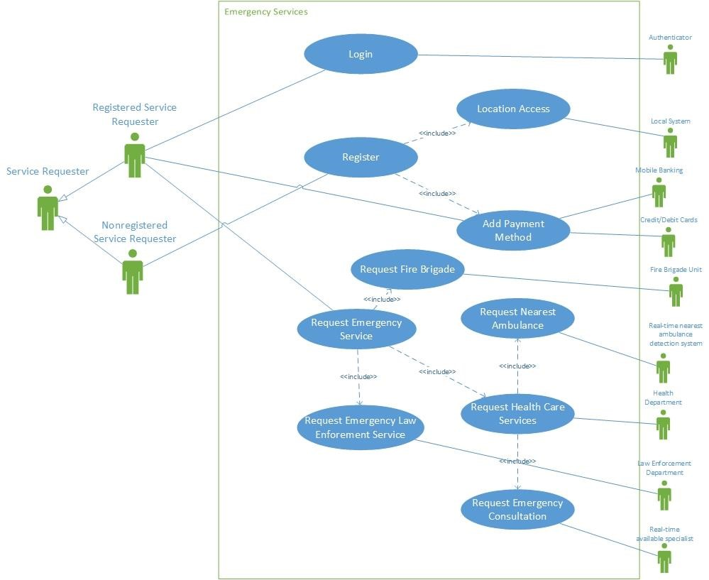
Class Diagram
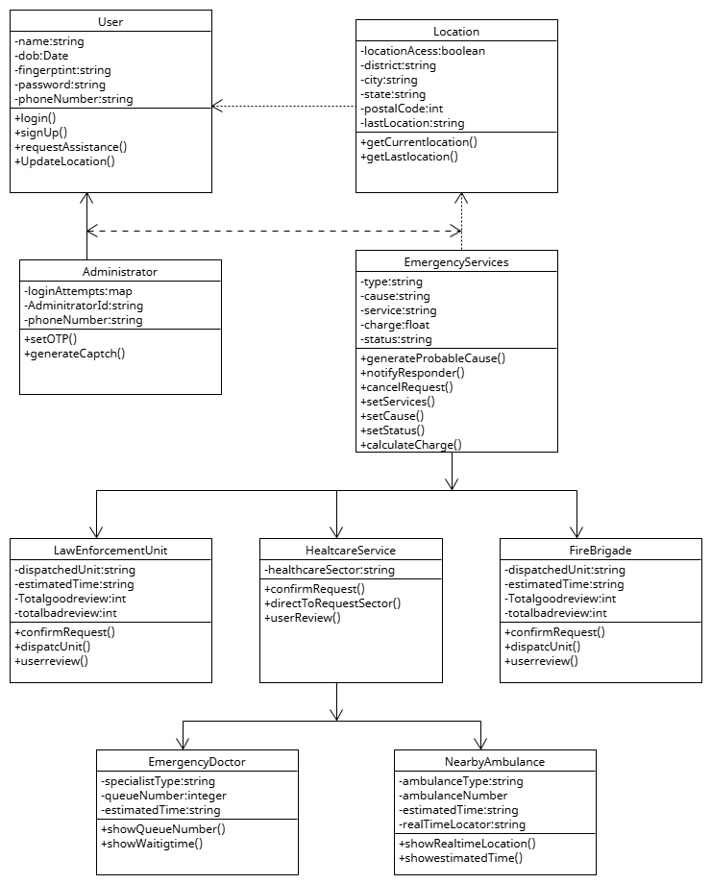
Sequence Diagram
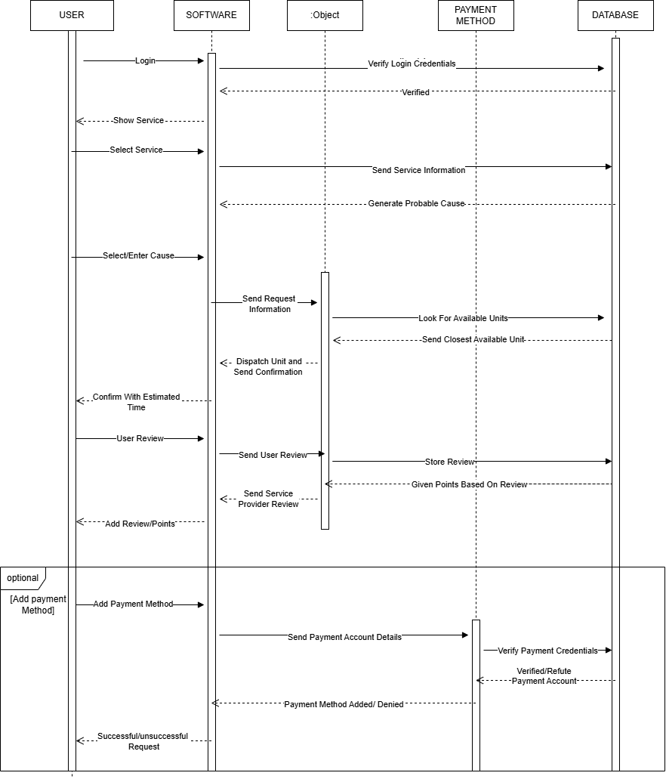

Activity Diagram
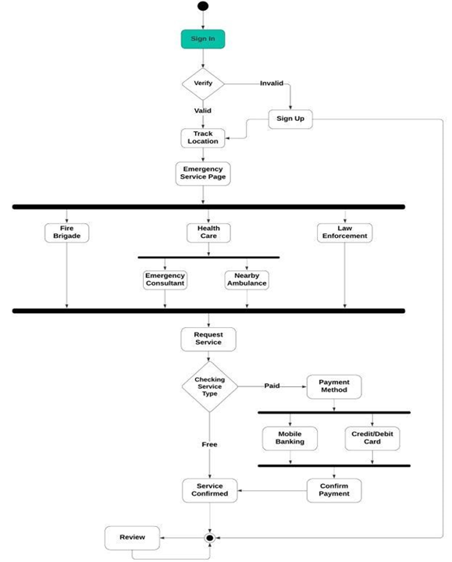

Functional Requirements
Track Last and Realtime Location
1. The software shall acquire permission to access the global positioning system embedded into the user’s system.
2. The software shall continuously monitor real-time location during active emergency services.
3. The software shall provide live map interface for the users and emergency responders.
4. The software shall handle any inaccuracies due to factors like signal interference.
5. the software can retrieve and display the last known location to the emergency responders if any connection problem occurs.
Priority Level: High
Precondition: User has a verified account registered on the software and has given location access to the software.
///////////////////////////////////////
1. Software Login
1.1 The software shall allow users to log in with their phone number and password.
1.2 The login credentials (phone number and password) will be verified within database records of registered users.
1.3 If correct credentials have been provided, an one-time password (OTP) will be sent to the users registered phone number to verify the ownership of the account.
1.4 If successfully logged in, the interactive home page of the user account will be displayed.
1.5 If wrong login credentials (phone number and password/ fingerprint) have been inserted, then a randomized captcha will appear to make sure the attempt was not made by an AI.
1.6 If 5 times wrong login credentials (phone number and password/ fingerprint) have been inserted, any further login attempt from the machine in question will be locked in an hour. The time will multiply by 3 on every set of wrong login attempts.

Priority Level: High
Precondition: Users have valid and registered phone numbers and password.
2. Software Signup
2.1 The software allows users to register with their phone number, password along with other information (name, dob, nid no. etc.).
2.2 The software shall ask the users to accept their terms and conditions.
2.3 The software shall verify the ownership of the phone number through a one-time password (OTP) sent to the registered phone number.
2.4 If successfully verified, the interactive home page of the user will be displayed.
2.5 The software shall prompt the users to give permission of the location service or the global positioning system (gps) of the user’s machine.
2.6 If location permission is given, the software shall let the users choose whether they want to add their insurance papers now or later, so that the charged amount for the emergency services gets covered by insurance agencies.
2.7 The software shall let the users add any available payment method (Bank transfer, mobile banking, online banking etc). The users can choose to add payment method later, then the default payment method will be added to the users account which is cash on delivery (COD).
2.8 If location permission is rejected, the software shall prompt the users to that location access is necessary to receive emergency services.
Priority Level: High Precondition: User have valid phone number.

3. Generate Probable Causes of Requests
3.1 The software shall fetch the information from the databases of the emergency services (fire brigade, health department, law enforcement department).
3.2 The software shall record all of the causes of the requests.
3.3 The software shall use all the fetched information and the recorded data generate multiple probably causes of the requests based on the geographical location of the users by using data analytics and artificial intelligence (AI).

Priority Level: High
Precondition: User has been logged in successfully into the software.

4. Request Fire Brigade
4.1 The software shall let the users request a fire brigade unit.
4.2 The software shall generate probable causes of the request.
4.3 The software shall let the users choose the cause of their request from the generated probable causes.
4.4 The software shall let the users call the emergency number if the generated probable causes doesn’t match with the causes of the users’ requests to let the emergency responders know the details about the emergency.
4.5 If the users select any one from the probable causes then the software shall let the users choose how severe the emergency is from three predefined options (high, medium, low).
4.6 The software shall then ask the users for the final confirmation of the request showing the estimated time of arrival.
4.7 If confirmed, the fire brigade unit will be notified immediately with the users’ information and based on the severity of the emergency one or multiple units will be assigned.
4.8 The software will keep on showing the real time location of the fire brigade and the location of the incident inside a well-coordinated map until the fire brigade units have successfully reached the location of the incident.
4.9 If cancelled, the software shall return the users to the home page.
Priority Level: High
Precondition: User has been successfully logged into the software.

5. Request Health Care Service
5.1 The software shall allow the users to request for health care services.
5.2 The software shall then ask the users to choose between two options (nearby ambulance, emergency consultant). If nearby ambulance has been selected by the users, The software shall allow the users to choose from the category of ambulances (premium, moderate, basic).
5.3 The software shall then ask the users to enter the name of the hospital they want to go.
5.4 The software shall then select the closest ambulance of the selected category within a 1km radius from the location of the users.
5.5 The software shall assign the request to the ambulance driver.
5.6 The software shall then show the real time location of both the ambulance and the requester along with the estimated time of arrival and the charged amount.
5.7 If an emergency consultant is selected in , the software shall allow the users to choose from the available specialists.
5.8 The software shall then connect the requester with the selected specialist through a video call.
Priority Level: High
Precondition: User has been successfully logged into the software.
6. Request Law Enforcement Unit
6.1 The software shall let the users to request for law enforcement unit(s).
6.2 The software shall generate probable causes of the request.
6.3 The software shall let the users choose the cause of their request from the generated probable causes.
6.4 The software shall let the users call the emergency number if the generated probable causes doesn’t match with the causes of the users’ requests to let the emergency responders know the details about the emergency.
6.5 If the users select any one from the probable causes then the software shall let the users choose how severe the emergency is from three predefined options (high, medium, low).
6.6 The software shall then ask the users for the final confirmation of the request showing the estimated time of arrival.
6.7 If confirmed, the nearest law enforcement unit will be notified immediately with the users’ information and based on the severity of the emergency one or multiple units will be assigned.
6.8 The software will keep on showing the real time location of the law enforcement unit and the users’ location inside a well-coordinated map until the law enforcement unit(s) have successfully reached the users’ location.
6.9 If cancelled, the software shall return the users to the home page.
Priority Level: High
Precondition: User has been successfully logged into the software.

7. After Service Review
7.1 After the service have been provided successfully, the software shall ask the users to give a review of the responders and vice versa.
7.2 This review will be added to the accounts of the users.
7.3 False requests will be penalized and an amount will be charged on the next request of the users in question.
7.4 The penalty will increase 5 times on each false request.
7.5 If no false request of fraudulent activity were found within 3 years then the amount will be set to the initial amount.

Priority Level: High
Precondition: User has a verified account registered on the software.

8. Track Last and Realtime Location
8.1 The software shall acquire the permission to access the global positioning system embedded into the user’s system.
8.2 The software shall continuously monitor real-time location during active emergency services.
8.3 The software shall provide live map interface for the users and emergency responders.
8.4 The software shall handle any inaccuracies due to factors like signal interference.
8.5 The software shall retrieve and display last known location to the emergency responders if any connection problem occurs.

Priority Level: High
Precondition: User has a verified account registered on the software and has given location access to the software.

9. Generate Penalties
9.1 The software shall ask the users to give their honest feedback or review of the service provider after the successful completion of the service.
9.2 The software shall then take the review and send it to the emergency service provider’s client and store the information into the database for future evaluation.
9.3 The software shall then ask the service providing units to give their honest feedback and comment on the legitimacy of the users.
9.4 These reviews will be added together with the users accounts and points will be generated based on the review (Negative points for negative reviews and positive points for positive reviews).
9.5 Based on these points, if enough negative point has been added to the users accounts, the software shall incorporate an pre stated amount for penalizing the users.
9.6 The software shall stop the user from requesting the services before the penalized amount has been paid.
Priority Level: High
Precondition: User has a verified account registered on the software. User has successfully taken any listed service.

Model Selection
For our project we will use the Incremental Development model.
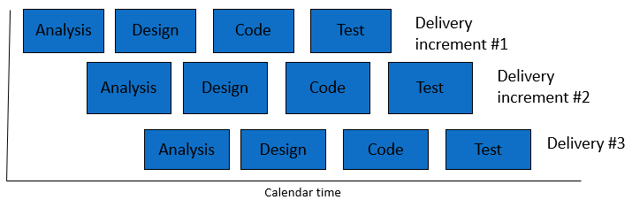
Incremental Development
Arguments:
The Incremental Development Model is the best approach for our emergency service system project because it offers several key benefits that match our project’s needs.
This model helps manage the complexity of our system. Since our project involves multiple features like real-time location tracking, request handling, secure login, and penalty management, the Incremental Model lets us develop and test each feature separately. For example, we can work on location tracking as one part, service requests as another, and penalty management as a third. This allows us to release each feature step-by-step and improve them as we go, making the development process more manageable.
The Incremental Model also allows us to get feedback throughout the project. Since our system will be used in high-pressure emergency situations, it’s important that we make updates based on real-world feedback from users and responders. Each feature can be improved as we progress, ensuring it meets actual needs and works well in real scenarios.
It is crucial to deliver core features early to reduce risks. The Incremental Model helps us launch essential functions, such as login, request handling, and tracking, in the first stages. This means the system will be useful to users right away, even while we develop more advanced features later on. By delivering in stages, we avoid the risks of waiting for the entire system to be finished before going live.
The Incremental Model helps with team and resource management. We can divide the project into smaller parts, so different teams can work on different features at the same time. This makes the development process faster and more efficient, allowing each team to focus on what they do best. This parallel approach makes the Incremental Model a practical and effective choice for our complex project.

Project Manager: The Project Manager provides coordination and oversight for iterative cycles of planning, development, and review. They ensure that resources, schedules, and scope are iteratively adjusted to accommodate evolving stakeholder input and requirements. The Project Manager primarily focuses on overseeing the incremental delivery of functional components while keeping in step with the project's big-picture objectives.
Business Analyst: The Business Analyst continuously elaborates on the project's requirements through close collaboration with stakeholders. The priorities of features in each iteration are determined based on client feedback and changing requirements. The Business Analyst ensures that the team stays aligned with the project's goals and that any changed requirements are properly documented throughout the process.
System Architect/Designer: The System Architect/Designer creates a system architecture to support iterative development. They design modular, scalable components that can be incrementally improved. At the end of each cycle, the designs and interfaces are updated to reflect findings and feedback, ensuring the system remains responsive to emerging requirements.
Development Team: The Development Team is responsible for delivering functional components through small iterative cycles. They develop features, integrate feedback from clients and testers into the code, and ensure it remains maintainable and adaptable for future increments. Their work focuses on achieving high-quality outcomes after each incremental delivery.
Test Team and Quality Assurance: After every iteration, the Test Team performs rigorous testing to ensure the functionality works as expected and identifies any bugs. They provide valuable feedback to the Development Team for defect resolution and ensure each incremental delivery meets the specified requirements. Their iterative testing ensures consistent quality and functionality improvement of the product.
Documentation Team: This team develops and updates project-related documentation throughout the system's lifecycle, including technical documents, user manuals, and specifications. Following each iteration, they document changes and enhancements to ensure the evolving system is well-documented and accessible.
Customer/Client: The Client is actively engaged in reviewing iterative deliverables to support continuous improvement. They approve incremental deliveries, provide insights for refinement, and collaborate with the project team to reassess priorities as the project unfolds.
Safety and Compliance Experts: These professionals continuously review the project to ensure every aspect of the process complies with safety and legal standards. As new features or components are developed, they update safety protocols and compliance measures to ensure adherence to the latest standards throughout the iterative process.
All roles emphasize key aspects such as flexibility, continuous feedback, and incremental improvement. This approach allows better adaptation to changing needs while ensuring collaboration and regulatory compliance.

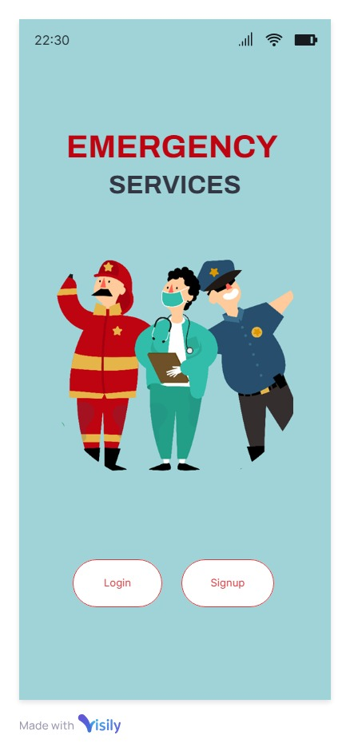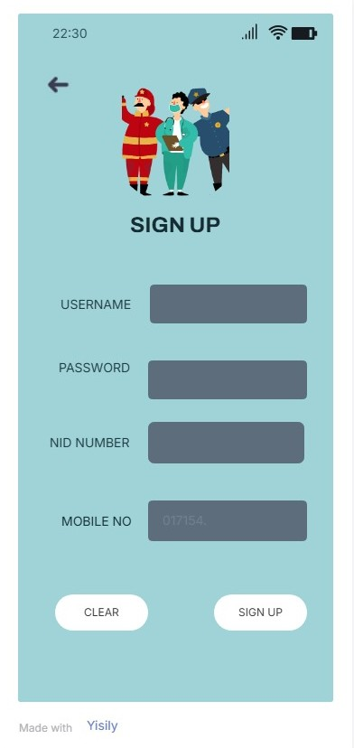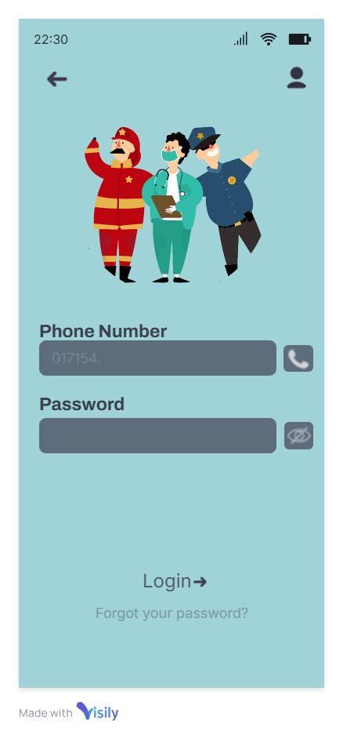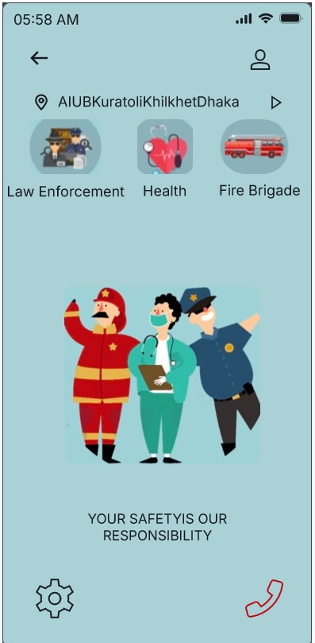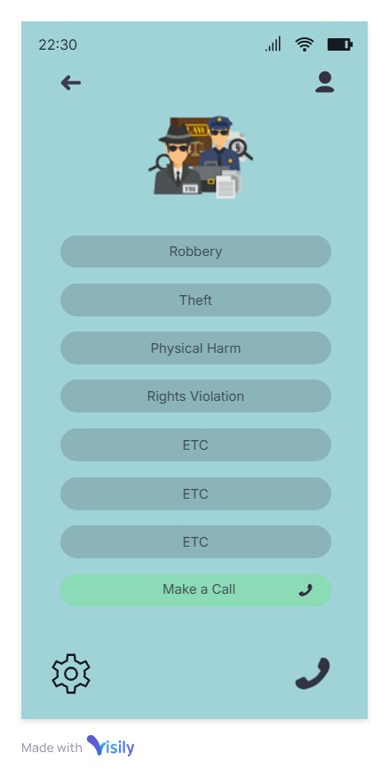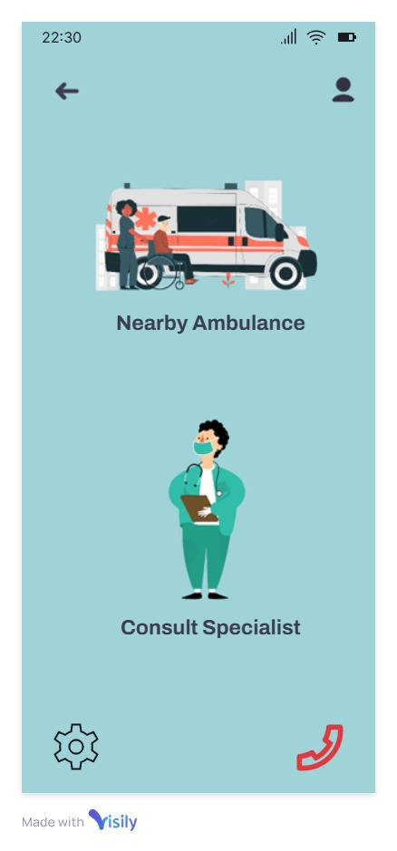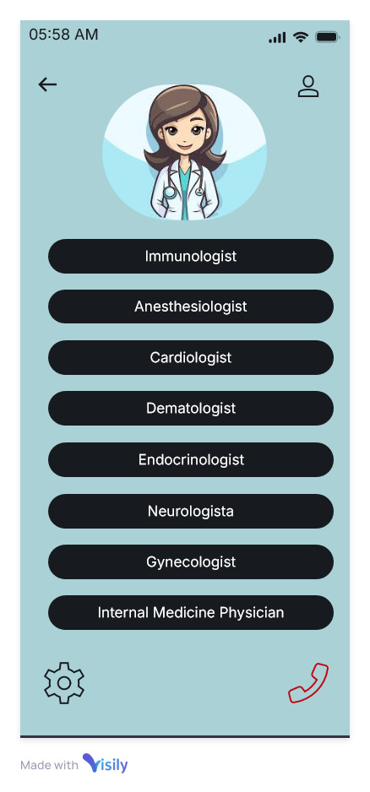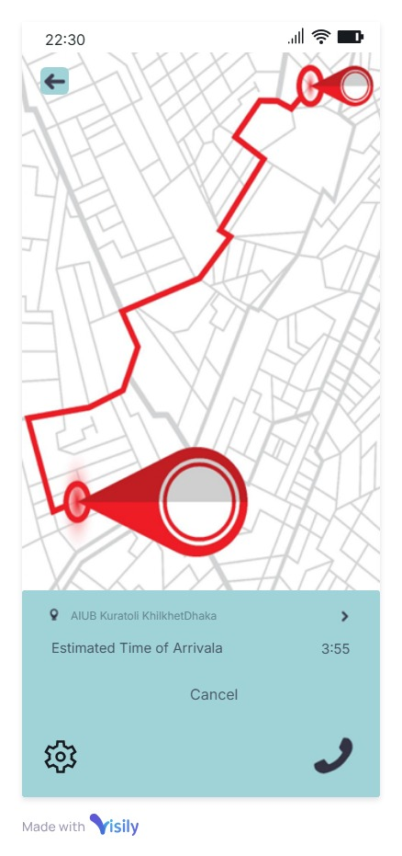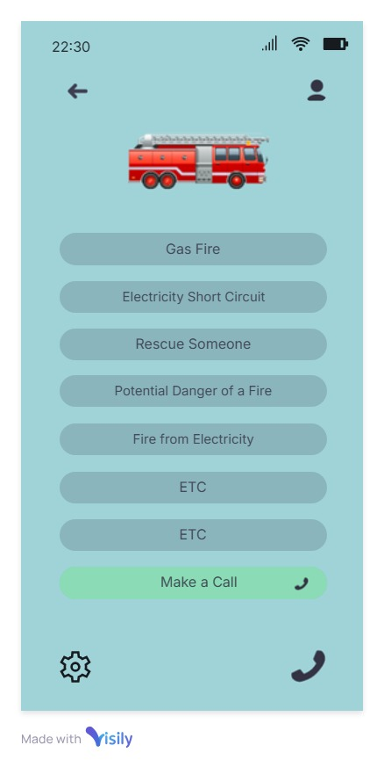
Bug report:
Project Name: Emergency Services |  |  | Test Designed by: Nipa
Test Case ID: FR_2  Test Priority (Low,Medium,High): High |  |  | Test Designed date: 4/ 12/ 2024 Test Executed by: Nipa
Module Name: Health Care Session |  |  | Test Execution date: 5/12/2024
Test Title: Request emergency consultant
Description: This test case ensures that a user can request an emergency consultant by choosing a listed specialist and connecting with the specialist via video conference.

Precondition (If any):
- The user has a valid internet connection.
- The user is logged into the system.
- Location services are enabled.

Test Steps | Test Data | Expected Results |  | Actual Results | Status  (Pass/Fail)
1. Login to the system  2. Select Heath Care services  3.Select Emergency  Consultant  4.Choose one from the list of specialists  5.Confirm your request | Specialist:  Cardiologist | The user successfully logs in, accesses health care services, selects an emergency consultant, chooses a specialist, and connects with them via video conference. |  | The user successfully logged in, accessed health care services, and selected a specialist, but the video conference connection with the specialist failed despite confirming the request. | Fail
Post Condition: 1. The information of the request is stored in the database.
2. A video call is conducted between the user and the selected specialist.

Project Name: Emergency services |  | Test Designed by: Sanjukta
Test Case ID: FR_3 |  | Test Designed date: 11-11-24
Test Priority (Low, Medium, High): Medium |  | Test Executed by: Sanjukta Das
Module Name: Emergency call handling test |  | Test Execution date: 2-12-24
Test Title: Validate real-time ambulance notification system
Description: Test notification system for nearby ambulance alerts Precondition
Precondition (If any): Ensure the notification service and location API are active
Test Steps | Test Data | Expected Results | Actual Results | Status (Pass/Fail)
1. Open the application  2. Enter pre-registered phone num  3. Enter valid password  4. Click Emergency Call  5. Click map icon | User Phone: 01234567891  Password: 12331 | User should receive a notification with the nearest ambulance details within 5 seconds Notification delay issue Fail | Maps algorithm bug problem | Fail
Post Condition: User is alerted with the nearest ambulance's real-time location for quick access.

Project Name: Emergency services |  | Test Designed by: fardin
Test Case ID: FR_4 |  | Test Designed date: 12-12-24
Test Priority (Low, Medium, High): Medium |  | Test Executed by: Ayman
Module Name: Law and Enforcement Session |  | Test Execution date: 12-12-24
Test Title: Dispatch law and enforcement unit
Description: Test law and enforcement dispatch
Precondition (If any):1. Valid internet connection
2.User Logged into system
3.Location service is enabled
Test Steps | Test Data | Expected Results | Actual Results | Status (Pass/Fail)
1. Login to the system  2. select law and enforcement  3. select severity  4. Assign unit according to the severity | Request:  Law Enforcement  Cause: Life Threating situation  Severity: Low | User should get the proper location of the ambulance and can track in real-time | Law and enforcement unit should be dispatched to the user’s location based on the severity of the emergency
Post Condition:
Project Name: Emergency services |  | Test Designed by: fardin
Test Case ID: FR_4 |  | Test Designed date: 12-12-24
Test Priority (Low, Medium, High): Medium |  | Test Executed by: Ayman
Module Name: Law and Enforcement Session |  | Test Execution date: 12-12-24
Test Title: Dispatch law and enforcement unit
Description: Test law and enforcement dispatch
Precondition (If any):1. Valid internet connection
2.User Logged into system
3.Location service is enabled
Test Steps | Test Data | Expected Results | Actual Results | Status (Pass/Fail)
1. Login to the system  2. select law and enforcement  3. select severity  4. Assign unit according to the severity | Request:  Law Enforcement  Cause: Life Threating situation  Severity: Low | User should get the proper location of the ambulance and can track in real-time | Law and enforcement unit should be dispatched to the user’s location based on the severity of the emergency
Post Condition:
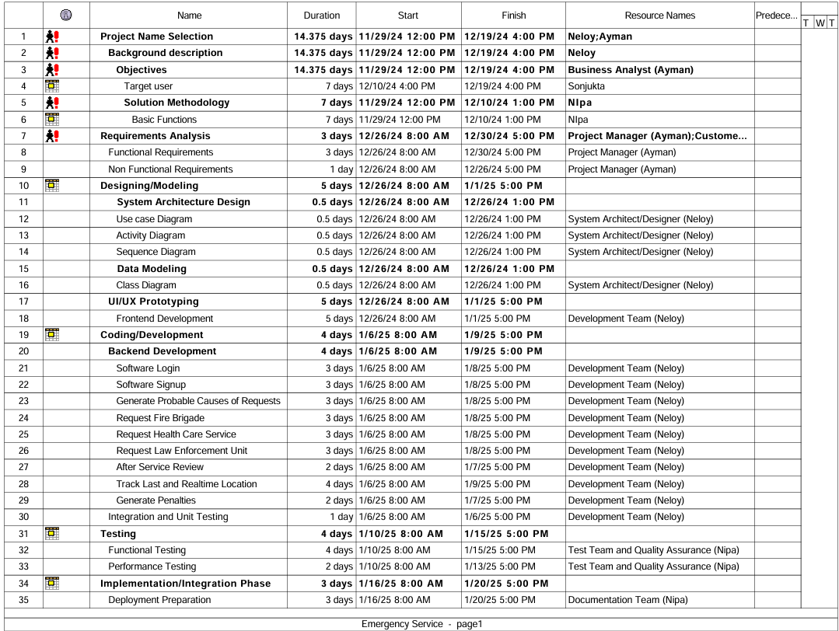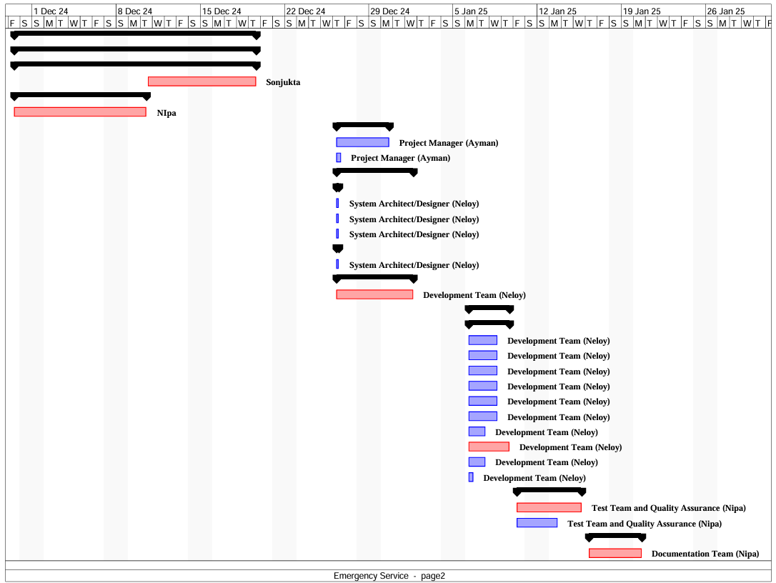
WBS:
